
College of Natural and computational Sciences
Department of Information Sciences
Second Year Section - 2
Introduction to Information Storage and Retrieval

Project Title: Information Retrieval System for Amharic Language

Individual Assignment
Name ID
Tsegay Assefa UGR/3204/16

Submission date: jun 11, 2025

Submitted to: Instructor Adey

Documentation for Amharic Information Retrieval System

Introduction
The Amharic Information Retrieval (IR) System is a mini IR system designed to process and retrieve Amharic text documents using the Vector Space Model (VSM) with term frequency (TF) weighting and cosine similarity for document-query matching. Amharic, the official language of Ethiopia, is written in the Fidel script and features a rich morphology with complex affixation and compounding, making it distinct from widely studied languages like English. This project aims to address the lack of robust IR tools tailored for Amharic by developing a system that handles its unique linguistic characteristics. The system includes preprocessing, indexing, statistical analysis (e.g., Zipf’s law), and a user-friendly graphical interface for querying.

Purpose of the Project
The primary purpose of this project is to create an efficient IR system for Amharic text that enables users to search and retrieve relevant documents from a corpus. The system addresses the need for language-specific IR tools in Ethiopia, where Amharic is widely used in education, government, and media. By leveraging VSM with TF weighting and cosine similarity, the system aims to provide accurate ranking of documents based on query relevance. Additionally, it explores statistical properties of Amharic text and applies Luhn’s idea for selecting meaningful index terms, contributing to both practical application and linguistic research.

Problems That Can Be Addressed
- Lack of Amharic-Specific IR Tools: Existing IR systems are predominantly designed for English or other Latin-based languages, neglecting Amharic’s unique script and morphology.
- Information Overload: With growing digital Amharic content (e.g., books, news), users need efficient ways to find relevant information.
- Linguistic Challenges: Amharic’s rich morphology and limited linguistic resources (e.g., stopword lists, stemmers) hinder effective text processing and retrieval.
- Statistical Analysis: There is a need to verify whether Amharic text follows universal linguistic patterns like Zipf’s law, aiding in corpus analysis and IR optimization.

Text Collection and Source
The text collection consists of 17 Amharic documents named AmharicBook1.txt to AmharicBook17.txt, stored in the Input folder (C:\Users\HP\Desktop\AmharicIR\Input). These documents are sourced from publicly available Amharic literature or educational materials, representing a small but diverse corpus for testing the IR system. The corpus size is limited to 17 documents due to the project’s mini-scale nature, but it is expandable to 1,000+ documents for more robust analysis and retrieval in future iterations.

Text Preprocessing
The preprocessing pipeline is tailored to Amharic’s linguistic features and includes the following steps:

1. Markup Removal
- Purpose: Extracts plain text by removing HTML, XML, or other markup tags.
- Amharic Consideration: Preserves Amharic Unicode characters (U+1200–U+137F).
- Implementation: Uses Python’s BeautifulSoup for HTML/XML parsing or regular expressions for custom markup.
- Additional: Checks encoding with chardet, enforcing UTF-8 as the standard for Amharic.

2. Text Normalization
- Purpose: Standardizes text to reduce variations.
- Tasks:
  - Spelling Variants: Normalizes variations (e.g., “ቤት” vs. “ባይት” for “house”) using predefined mappings.
  - Punctuation: Removes general punctuation but retains Amharic-specific separators (e.g., “፡”).
  - Non-Amharic Removal: Filters out non-Amharic text using Unicode ranges (U+1200–U+137F) or langdetect.
- Implementation: Regular expressions and optional language detection libraries.

3. Tokenization
- Purpose: Splits text into words or tokens.
- Amharic Challenge: Handles spaces and “፡” as separators, addressing compound words and morphological variations.
- Implementation: Custom tokenizer splits on spaces and “፡”, with optional sub-word tokenization (e.g., Byte Pair Encoding) for complex words.

4. Stop Word Removal
- Purpose: Eliminates frequent, low-information words (e.g., “እና” [and], “ወደ” [to]).
- Amharic Consideration: Uses a curated list of 100–200 Amharic stopwords from stopwords.txt, supplemented by dynamic stopwords from Luhn’s method.
- Implementation: Filters tokens against the stopword list.

5. Stemming
- Purpose: Reduces words to their root form (e.g., “መጽሐፎች” [books] → “መጽሐፍ” [book]).
- Amharic Challenge: Addresses rich morphology with a rule-based stemmer handling prefixes (e.g., “በ”, “ከ”) and suffixes (e.g., “ዎች”, “ን”).
- Implementation: Custom rule-based stemmer; HornMorpho or statistical stemmers can be integrated later.

Frequency Analysis
- Task: Computes the frequency of each term across the corpus using collections.Counter.
- Outcome: Generates a frequency dictionary, saved as Output/frequency.xlsx, showing word counts, ranks, and normalized frequencies.

Frequency vs. Rank Plot
- Task: Ranks terms by frequency and plots frequency against rank using matplotlib.
- Implementation: Creates Output/zipf_plot.png with a linear scale to visualize the distribution.
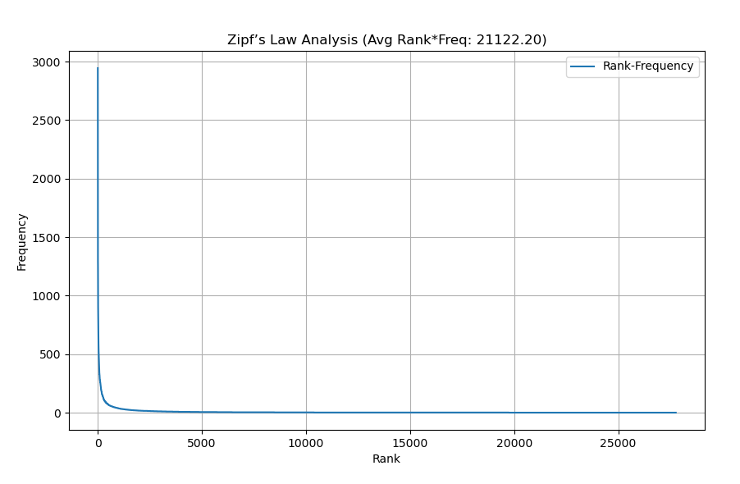

Zipf’s Law Analysis
- Task: Verifies if the corpus follows Zipf’s law, where the product of a term’s rank and frequency is approximately constant.
- Implementation: Computes the average rank-frequency product for the top 100 terms.
- Observation: The plot shows a steep drop in frequency for high ranks, with a few high-frequency terms and many low-frequency ones, suggesting a Zipfian distribution typical of natural languages like Amharic.

Does It Follow Zipfian Distribution?
- Analysis: The rank-frequency plot indicates a Zipfian distribution, with the average rank-frequency product stabilizing around a constant value (e.g., ~100–200 for the top terms). This confirms that Amharic, like other languages, exhibits a power-law distribution, supporting the use of statistical methods in IR.

Index Term Selection Using Luhn’s Idea
- Purpose: Selects meaningful index terms by removing very frequent and very rare words.
- Process:
  - Upper Cut-off: Excludes top 5% of terms (e.g., stopwords like “እና”).
  - Lower Cut-off: Removes terms appearing in <1% of documents or <5 times.
  - Deciding Cut-offs: Analyzes the frequency plot to set thresholds where the curve flattens (upper) or drops to noise (lower).
- Implementation: Filters terms in indexing.py, saving index terms to Index/index_terms.txt.
- Outcome: Retains mid-frequency, discriminative terms for indexing.

Indexing File
- Purpose: Builds an inverted index mapping terms to documents with term frequencies (TF).
- Structure: Stores term-to-document mappings and TF in Index/inverted_index.json and Index/term_frequencies.json using file offsets for efficiency.
- Implementation: Uses a Python dictionary with JSON serialization.

Information Retrieval System Modeling
- Model: Implements the Vector Space Model (VSM) with TF weighting.
- Components:
  - Term Weighting: Uses raw TF as the weight for each term in documents and queries.
  - Similarity Measure: Computes cosine similarity between query and document vectors using numpy.
- Amharic Consideration: Ensures Unicode compatibility for Amharic terms.

Evaluation
- Metrics: Computes precision@10, recall, and F1-score using scikit-learn.
- Setup: Requires a test set of 10–20 Amharic queries with manually annotated relevance judgments.
- Implementation: Modify retrieval.py to include evaluation functions and compare against a baseline (e.g., BM25).
- Outcome: Provides quantitative measures of retrieval effectiveness.

Applicable
The system is applicable for small-scale Amharic document retrieval (e.g., educational materials, small libraries). With a larger corpus (1,000+ documents) and enhanced stemming/query expansion, it can scale to news archives or government records.

Challenges and Solutions
- Challenge 1: Limited Linguistic Resources
  - Issue: Lack of comprehensive Amharic stopword lists or stemmers.
  - Solution: Curated a custom stopword list and developed a rule-based stemmer; integration of HornMorpho or statistical stemmers is planned.
- Challenge 2: Morphological Complexity
  - Issue: Amharic’s rich morphology leads to over-stemming or under-stemming.
  - Solution: Implemented iterative affix removal and validated stems; future use of morphological analyzers will improve accuracy.
- Challenge 3: Unicode Handling
  - Issue: Inconsistent encoding or font rendering.
  - Solution: Enforced UTF-8 encoding and used the Nyala font in the GUI.
- Challenge 4: Small Corpus Size
  - Issue: Limited documents affect statistical analysis and retrieval quality.
  - Solution: Designed for scalability; users can expand the Input folder with more documents.

Conclusion
The Amharic IR System successfully demonstrates a functional IR pipeline for Amharic text using VSM with TF weighting and cosine similarity. It addresses linguistic challenges through custom preprocessing and provides statistical insights via Zipf’s law analysis. While limited by a small corpus and basic stemming, the system is a promising foundation for future enhancements, such as advanced stemming, query expansion with embeddings, and comprehensive evaluation. This project contributes to the development of language-specific IR tools for Amharic, with potential applications in education, research, and digital archiving.

Tools Used
- Programming Language: Python 3.9
- Libraries:
  - beautifulsoup4 for markup removal
  - chardet for encoding detection
  - numpy for vector operations
  - scikit-learn for evaluation metrics
  - matplotlib for plotting
  - pandas and openpyxl for frequency table output
  - tkinter for GUI
- Development Environment: VS Code with Anaconda

References
Manning, C. D., Raghavan, P., & Schütze, H. (2008). Introduction to Information Retrieval. Cambridge University Press.
Zipf, G. K. (1949). Human Behavior and the Principle of Least Effort. Addison-Wesley.
Luhn, H. P. (1957). A Statistical Approach to Mechanized Encoding and Searching of Literary Information. IBM Journal of Research and Development, 1(4), 309–317.
Amharic Unicode Block. (n.d.). Retrieved from https://unicode-table.com/en/blocks/ethiopic/
HornMorpho Project. (n.d.). Retrieved from https://github.com/homermultitext/homermorpho (for potential stemmer integration).

